**Analyzing a Line Graph – An Exercise**

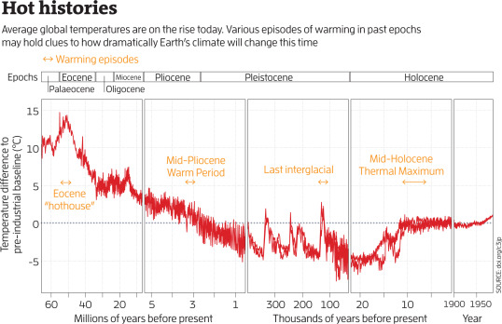

G. Lawton, “Climate's future written in rocks”, *NewScientist,* 6 July 2019, pp. 38-42